Project Specification and Sprint Work – LockeMe.com (Phase I project)

|  |  |  |  |
| --- | --- | --- | --- |
| Revision History | | | |
| Version no | Description | Author | Date of change |
| v0 | Initial version of LockMe.com project | Nandakumar R | 10 Aug 2021 |

Table of Contents

Introduction 4

Product’s capabilities 4

Appearance 4

Menu Options: 5

User interactions 6

Number and duration of sprints 6

Git and GitHub account 6

Java concepts 6

Source Code 7

Introduction:

Company Lockers Pvt. Ltd. need to digitize their products and chose LockedMe.com as their first project to start with. Need to develop a prototype of the application. The prototype of the application needs to be presented to the relevant stakeholders for budget approval.

Product’s capabilities:

LockMe.com product need to have below specifications as follows

1. Retrieving the file names in an ascending order
2. Business-level operations:
   * Option to add a user-specified file to the application
   * Option to delete a user-specified file from the application
   * Option to search a user-specified file from the application
   * Navigation option to close the current execution context and return to the main context
3. Option to close the application.

Appearance:

Project Folder Structure:

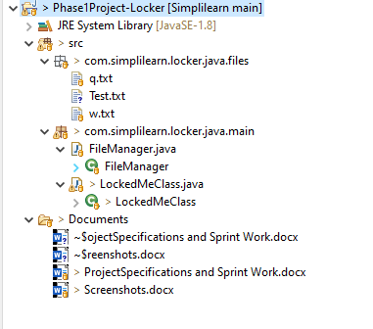

Class Outline:

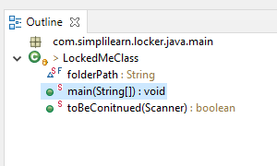

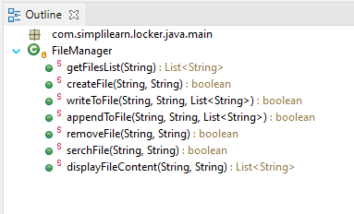

Menu Options:

Below are the menu options provided to the application users to perform

1. Create a New File

2. Write Contents to File

3. Append to contents to File

4. Search for a File

5. Display Contents of a File

6. Delete a File

7. List all File Availble in Folder

8. Exit

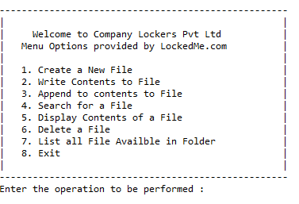

User interactions:

Users can interact to the application via console to provide options to perform any operations provided in the application.

Number and duration of sprints:

Sprints planned for this project is as in below Table:

|  |  |  |  |  |
| --- | --- | --- | --- | --- |
| Sprint No | Module Planned | Start Date | End Date | Hours Planned |
| 1 | Prototype Designing with Menu Options | 08 Aug 2021 | 08 Aug 2021 | 2 |
| 2 | Working on Menu options | 09 Aug 2021 | 10 Aug 2021 | 3 |
| 3 | Final Demo to Customer for Business sign-off | 11 Aug 2021 | 11 Aug 2021 | 1 |

Git and GitHub account:

Git account where the source code is maintained: <https://github.com/NandakumarRangnathan/Phase-1---Java-Class/tree/main/Phase1Project-Locker>

Java concepts:

Java concepts being used in the project as below

1. Collections
2. List
3. Arrays
4. File and File Handling techniques
5. Scanner
6. Exception Handling

Source Code:

Below is the source code form the project

**LockedMeClass.class**

package com.simplilearn.locker.java.main;

import java.io.IOException;

import java.util.ArrayList;

import java.util.InputMismatchException;

import java.util.List;

import java.util.Scanner;

public class LockedMeClass {

static final String folderPath = "C:\\Needs\\Simplilearn\\Phase1Project-Locker\\src\\com\\simplilearn\\locker\\java\\files";

public static void main(String[] args) {

Scanner obj = new Scanner(System.in);

String fileName;

int lineCount, performOperation;

boolean isDeleted = false, isCreated = false, isAvailable = false, needToContinue = false, isWritten = false;

List<String> content = new ArrayList<String>();

String welcomeMessage = " " + "\n----------------------------------------------------"

+ "\n| |"

+ "\n| Welcome to Company Lockers Pvt Ltd |"

+ "\n| Menu Options provided by LockedMe.com |"

+ "\n| |"

+ "\n| 1. Create a New File |"

+ "\n| 2. Write Contents to File |"

+ "\n| 3. Append to contents to File |"

+ "\n| 4. Search for a File |"

+ "\n| 5. Display Contents of a File |"

+ "\n| 6. Delete a File |"

+ "\n| 7. List all File Availble in Folder |"

+ "\n| 8. Exit |"

+ "\n| |"

+ "\n----------------------------------------------------";

do {

try {

System.out.println(welcomeMessage);

System.out.println("Enter the operation to be performed : ");

performOperation = obj.nextInt();

switch (performOperation) {

case 1:

// Creating a New file in the location.

System.out.println("Enter File Name to be created : ");

fileName = obj.next();

isCreated = FileManager.createFile(fileName, folderPath);

if (isCreated)

System.out.println("File created with name : " + fileName);

needToContinue = toBeConitnued(obj);

break;

case 2:

// Writting contents to the file which user secified

System.out.println("Enter the file Name to write the contents to it : ");

fileName = obj.next();

System.out.println("Enter the number of lines to be written to File : ");

lineCount = obj.nextInt();

System.out.println("Enter the content : ");

for (int i = 0; i <= lineCount; i++) {

content.add(obj.nextLine());

}

isWritten = FileManager.writeToFile(folderPath, fileName, content);

if (isWritten)

System.out.println("Written the contents the File");

else

System.out.println("Not written to the file");

needToContinue = toBeConitnued(obj);

break;

case 3:

System.out.println("Enter the file Name to append the contents to it : ");

fileName = obj.next();

System.out.println("Enter the number of lines to be appended to File : ");

lineCount = Integer.parseInt(obj.next());

System.out.println("Enter the content of line : ");

for (int i = 0; i <= lineCount; i++) {

content.add(obj.nextLine());

}

if (FileManager.serchFile(folderPath, fileName))

isWritten = FileManager.appendToFile(folderPath, fileName, content);

if (isWritten)

System.out.println("Written the contents the File");

else

System.out.println("We dont find the file to append the content");

needToContinue = toBeConitnued(obj);

break;

case 4:

// Searching a File

System.out.println("Enter the file name to be searched : ");

fileName = obj.next();

isAvailable = FileManager.serchFile(folderPath, fileName);

if (isAvailable)

System.out.println("File is present in the folder");

else

System.out.println("File not present in the folder");

needToContinue = toBeConitnued(obj);

break;

case 5:

// Displaying content a File

System.out.println("Enter the file name to be displayed : ");

fileName = obj.next();

isAvailable = FileManager.serchFile(folderPath, fileName);

if (isAvailable) {

List<String> diplayList = FileManager.displayFileContent(folderPath, fileName);

if (diplayList.isEmpty()) {

System.out.println("File has no content to disply Now");

} else {

diplayList.forEach((n) -> System.out.println(n));

}

} else

System.out.println("File not present in the folder");

System.out.println("\n");

needToContinue = toBeConitnued(obj);

break;

case 6:

// File to be deleted.

System.out.println("Enter the file name to be deleted : ");

fileName = obj.nextLine();

isDeleted = FileManager.removeFile(folderPath, fileName);

if (isDeleted)

System.out.println(fileName + " - File deleted successfully");

else

System.out.println("We dont see file named :" + fileName);

needToContinue = toBeConitnued(obj);

break;

case 7:

// Getting List of Files in the Folder in ascending order.

List<String> fileList = FileManager.getFilesList(folderPath);

if (!fileList.isEmpty()) {

System.out.println("Files available in the folder are below : ");

fileList.forEach((n) -> System.out.println(n));

} else {

System.out.println("Folder is empty.");

}

needToContinue = toBeConitnued(obj);

break;

case 8:

System.exit(0);

needToContinue = false;

break;

default:

System.out.println("You have provided a wrong option.");

needToContinue = toBeConitnued(obj);

break;

}

} catch (InputMismatchException e) {

System.out.println("Please input a valid Menu option to perform");

main(args);

}

} while (needToContinue);

}

public static boolean toBeConitnued(Scanner obj) {

System.out.println("Do you want to Continue : Yes or No");

String userInput = obj.next();

if (userInput.equalsIgnoreCase("Yes"))

return true;

else

return false;

}

}

**FileManager.class**:

**package com.simplilearn.locker.java.main;**

**import java.io.BufferedReader;**

**import java.io.BufferedWriter;**

**import java.io.File;**

**import java.io.FileNotFoundException;**

**import java.io.FileReader;**

**import java.io.FileWriter;**

**import java.io.IOException;**

**import java.util.ArrayList;**

**import java.util.Collections;**

**import java.util.List;**

**public class FileManager {**

**public static List<String> getFilesList(String filePath) {**

**// Variable declaration**

**List<String> al = new ArrayList<String>();**

**// Creating File Object**

**File fileList = new File(filePath);**

**// Getting list of files available in folder**

**String[] listOfFiles = fileList.list();**

**// looping through file array**

**for (String file : listOfFiles)**

**al.add(file);**

**Collections.sort(al);**

**return al;**

**}**

**public static boolean createFile(String fileName, String filePath) {**

**File file = new File(filePath, fileName);**

**boolean isFielCreated = false;**

**try {**

**if (file.createNewFile())**

**isFielCreated = true;**

**} catch (IOException e) {**

**// TODO Auto-generated catch block**

**e.printStackTrace();**

**}**

**return isFielCreated;**

**}**

**public static boolean writeToFile(String path, String fileName, List<String> fileContent) {**

**try {**

**File f = new File(path, fileName);**

**FileWriter fw = new FileWriter(f);**

**if (!f.exists())**

**f.createNewFile();**

**for (String s : fileContent) {**

**if (s.length() > 0)**

**fw.write(s + "\n");**

**}**

**fw.close();**

**return true;**

**} catch (IOException e) {**

**// TODO Auto-generated catch block**

**e.printStackTrace();**

**return false;**

**}**

**}**

**public static boolean appendToFile(String path, String fileName, List<String> fileContent) {**

**try {**

**BufferedWriter out = new BufferedWriter(new FileWriter(path + "\\" + fileName, true));**

**fileContent.forEach((n) -> {**

**try {**

**if (n.length() > 0)**

**out.write(n + "\n");**

**} catch (IOException e) {**

**// TODO Auto-generated catch block**

**e.printStackTrace();**

**}**

**});**

**// out.write(str);**

**out.close();**

**return true;**

**} catch (Exception e) {**

**// TODO: handle exception**

**}**

**return false;**

**}**

**public static boolean removeFile(String filePath, String fileName) {**

**File fl = new File(filePath + "\\" + fileName);**

**try {**

**if (fl.delete())**

**return true;**

**} catch (Exception e) {**

**// TODO: handle exception**

**}**

**return false;**

**}**

**public static boolean serchFile(String filePath, String fileName) {**

**File fl = new File(filePath + "//" + fileName);**

**try {**

**if (fl.exists())**

**return true;**

**} catch (Exception e) {**

**// TODO: handle exception**

**}**

**return false;**

**}**

**public static List<String> displayFileContent(String filePath, String fileName){**

**BufferedReader br;**

**List<String> al = new ArrayList<String>();**

**try {**

**br = new BufferedReader(new FileReader(filePath + "//" + fileName));**

**String line;**

**while ((line = br.readLine()) != null) {**

**al.add(line);**

**}**

**} catch (FileNotFoundException e) {**

**// TODO Auto-generated catch block**

**e.printStackTrace();**

**} catch (IOException e) {**

**// TODO Auto-generated catch block**

**e.printStackTrace();**

**}**

**return al;**

**}**

**}**